

Querying with Transact-SQL

Getting Started

# Overview

Transact-SQL is an essential skill for database professionals and developers working with Microsoft SQL Server or Microsoft Azure SQL Database. This course combines online presentations with hands-on labs that will give you practical experience and a chance to test and extend your Transact-SQL programming skills.

To complete the labs in this course, you will need to set up a lab environment that includes the **AdventureWorksLT** sample database. This document explains how to achieve this using Microsoft Azure SQL Database, a cloud-based relational database service.

Each module in this course consists of:

* An online video presentation.
* A hands-on lab.

The recommended approach for this course is to complete each module in turn; first watching the online presentation, and then completing the lab. Then, when you’re comfortable with what you’ve learned, move onto the next module and repeat the process. You can complete the course as quickly or slowly as you want, though we recommend pacing yourself to ensure that you absorb the lessons from each module before progressing to the next one.

Each lab consists of a document that contains a number of progressively complex challenges, which you should be able to complete by using the information that was presented in the online presentation as well as the references to further information that are provided in the lab itself. Suggested solution scripts are provided for each lab.

# What You’ll Need

* A web browser
* A Microsoft account
* A Microsoft Azure subscription
* A Microsoft Windows computer with either of the following tools installed:
  + Microsoft SQL Server Management Studio
  + Microsoft Visual Studio

# Creating a Free Trial Azure Subscription

If you already have a Microsoft Azure subscription, you can skip this section. Otherwise, follow these steps to create a free trial subscription:

1. If you already have a Microsoft account that has not already been used to sign up for a free Azure trial subscription, you’re ready to get started. If not, don’t worry, just create a new Microsoft account at <https://signup.live.com>.
2. After you’ve created a Microsoft account, browse to [http:\azure.microsoft.com\en-us\pricing\free-trial\?WT.mc_id=14727-DEV-dev-ec_azuretrial_mva-posts](http://azure.microsoft.com/en-us/pricing/free-trial/?WT.mc_id=14727-DEV-dev-ec_azuretrial_mva-posts) and follow the instructions to sign up for a free trial subscription to Microsoft Azure. You’ll need to sign-in with your Microsoft account if you’re not already signed in. Then you’ll need to:
   1. Enter your cellphone number and have Microsoft send you a text message to verify your identity.
   2. Enter the code you have been sent to verify it.
   3. Provide valid payment details – don’t worry, your credit card won’t be charged for any services you use during the trial period, and the account is automatically deactivated at the end of the trial period unless you explicitly decide to keep it active.

# Create an Azure SQL Database

Now that you have an Azure subscription, you can create an Azure SQL Database instance to use in the labs.

1. Browse to <http://portal.azure.com>. If you are prompted to sign in, do so with the Microsoft account that is associated with your Azure subscription. At the time of writing, this portal is in preview.

**Note**: The Azure portal is updated frequently, and may not look exactly the same as the images in this document.

1. In the Hub menu (the vertical bar on the left), click **New** (indicated by a **+**), and then in the **New** blade that appears, click **Data and Storage**, and then click **SQL Database**.

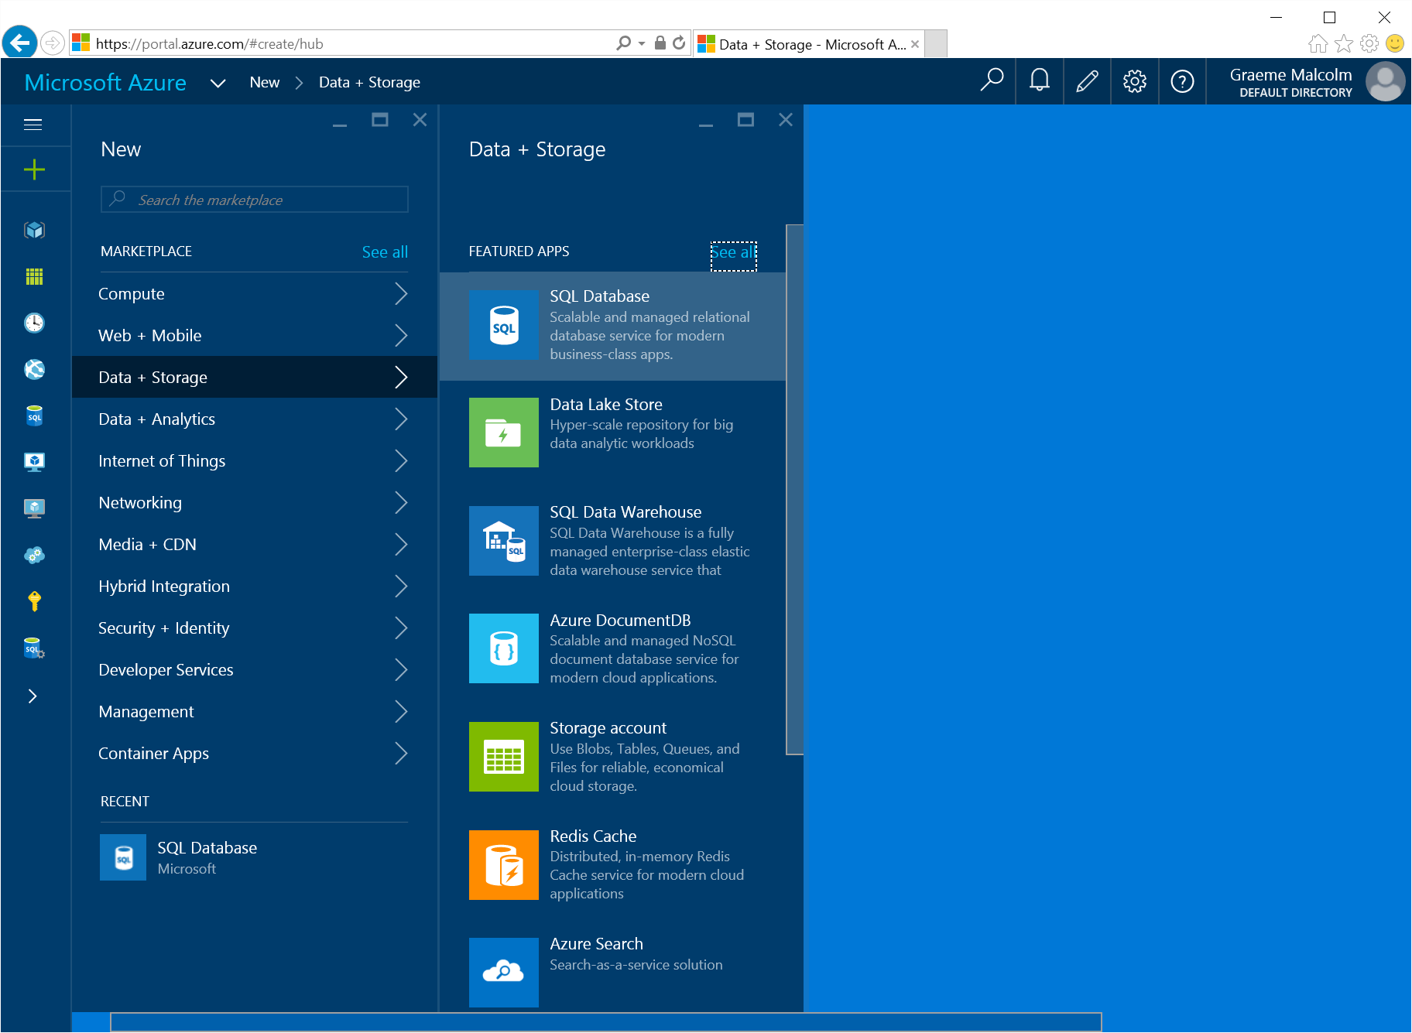

1. In the SQL database blade:
   1. Enter the name **AdventureWorksLT**
   2. Click **Server**. Then click **Create a new server** and enter the following details and click **OK**.
      * A unique name for your server (a pink exclamation mark will be displayed if the name you have entered is unavailable, otherwise a green tick is shown)
      * A user name you want to assign to the server administrator. This can be your name or some other name you’ll remember easily – however, you cannot use “Administrator”.
      * A password for your server administrator account. This must meet the password complexity rules for Azure SQL database, so for example it cannot be blank or “password”.
      * The location where your server should be hosted. Choose the location nearest to you.

**Note**: At the time of writing, the latest version of Azure SQL Database is V12. If this version is available in your regions, select it.

* + - Leave the option to allow Azure services to access the server selected (this opens an internal firewall port in the Azure datacenter to allow other Azure services to use the database).
  1. Click **Select Source**, and select **Sample**.
  2. In the **Select Sample** section, ensure that **AdventureWorksLT** is selected. If you created a V12 server, select the V12 version of the database)
  3. Ensure that your selections are similar to those below, and click **Create**.

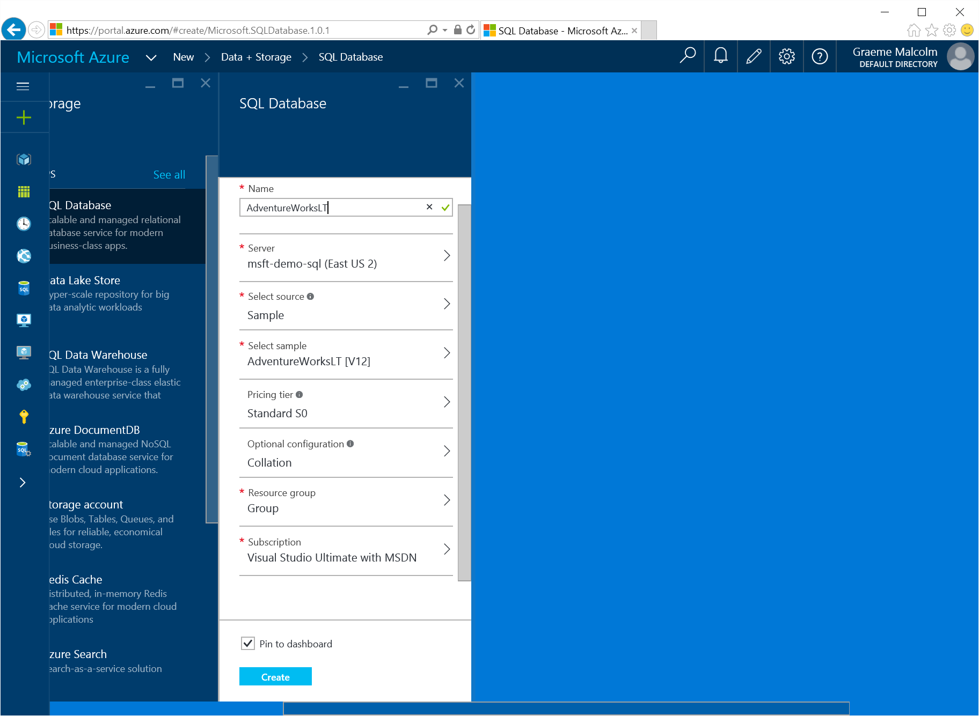

1. After a short time, your SQL Database will be created and displayed on the Start board, and the blade for your **AdventureWorksLT** database should be opened (if not, click the **AdventureWorksLT** **SQL Database** icon on the Start board).

# Configure Firewall Rules for your Azure SQL Database Server

1. In the blade for your **AdventureWorksLT** Azure SQL database, click the server name (which should be in the format ***server_name*.database.windows.net** as shown in the following image:

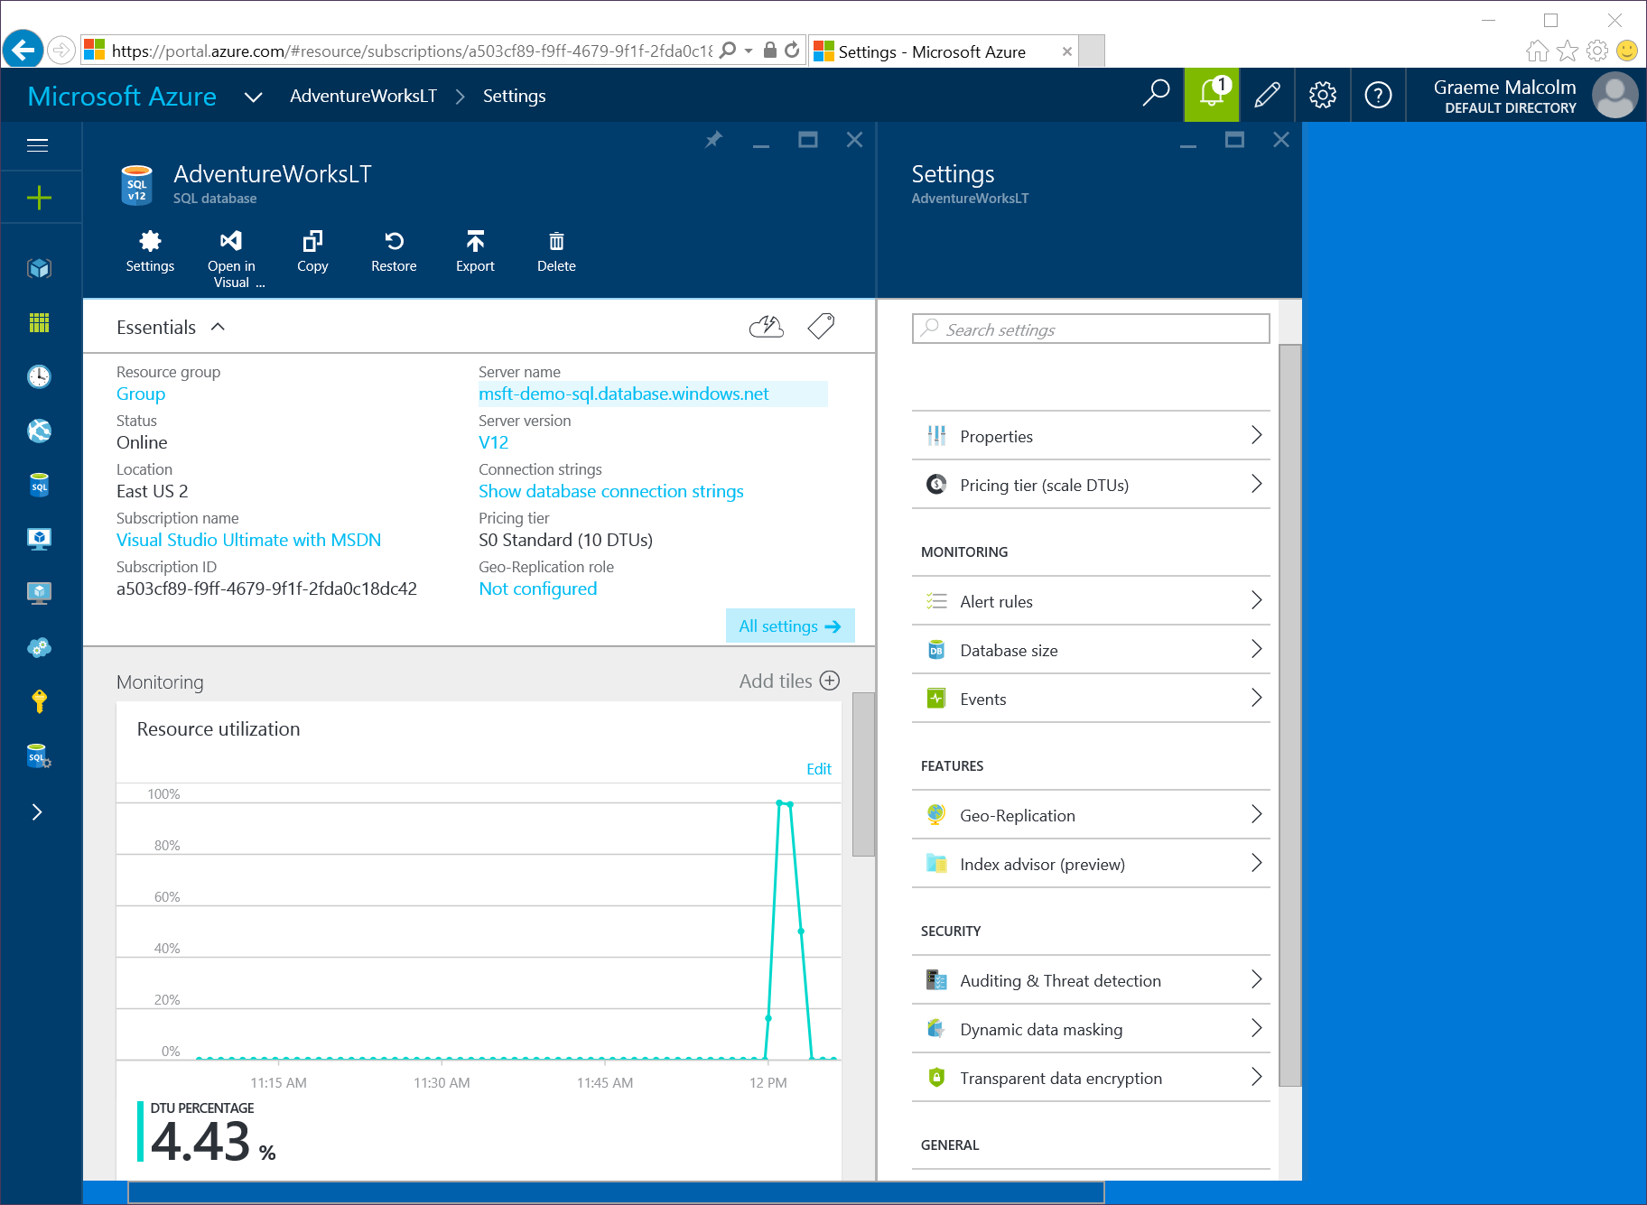

1. In the **Settings** blade for your server, click **Firewall**:

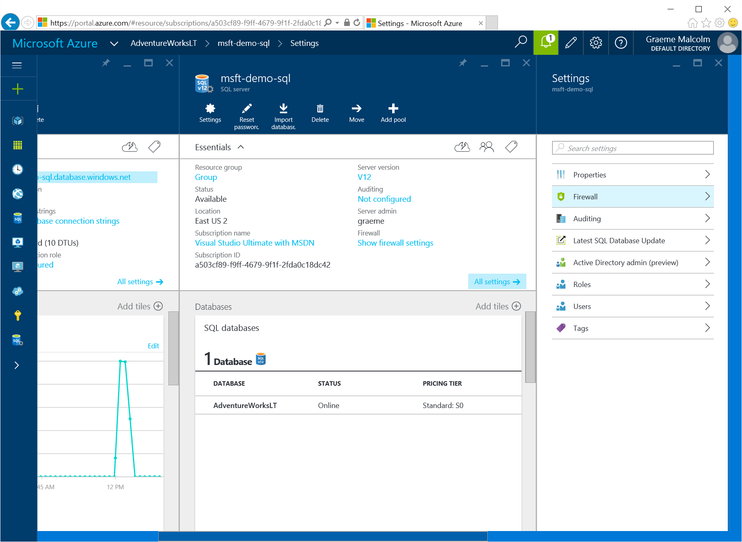

1. In the Firewall Settings blade, note that your client IP address has been automatically identified. Then enter a new rule with a start IP and end IP matching your client IP address, and click **Save** to update the firewall rules.

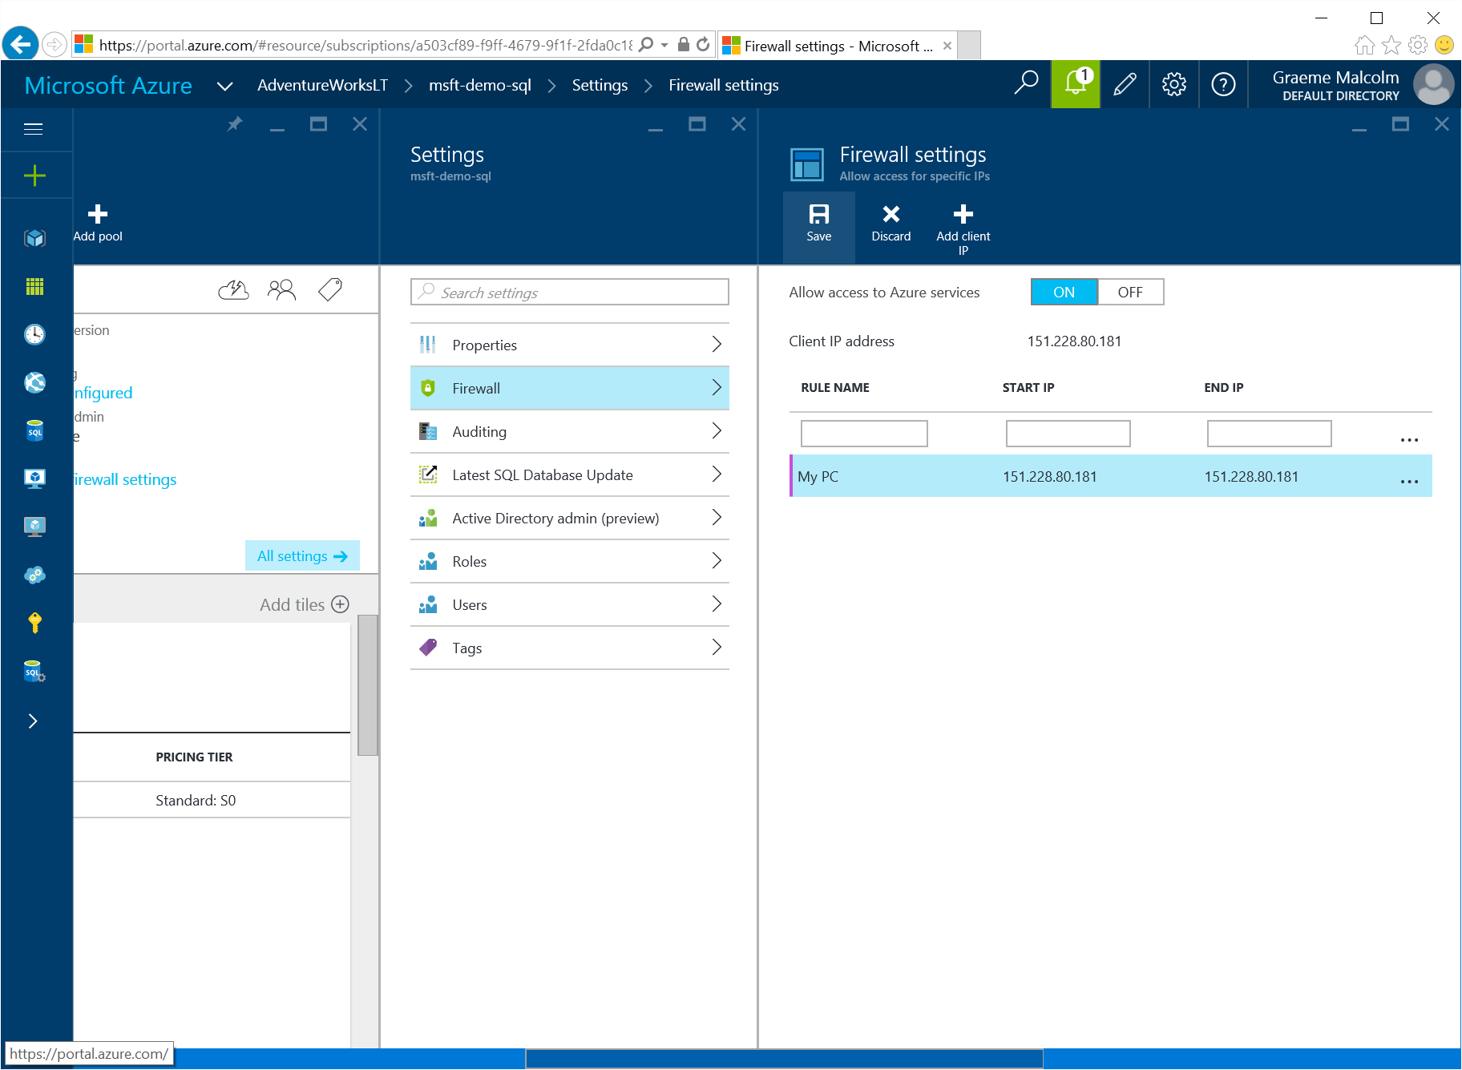

**Note**: Azure SQL Database uses firewall rules to control access to your database. If your computer’s public-facing IP address changes (or you want to use a different computer), you’ll need to repeat this step to allow access. Alternatively, you can create a firewall rule that allows access from a range of IP addresses – to allow access from any computer connected to the Internet, you can create a rule with a start IP of 0.0.0.0 and an end IP of 255.255.255.255 (this is not recommended for production databases).

# Installing and Connecting from a Client Tool

You can use either of the following tools to develop your Transact-SQL queries.

**Note**: These tools are designed for Microsoft Windows. If you are using a non-Windows computer, you can install a third-party SQL Server client application for your platform. Microsoft provides no endorsement or support for non-Microsoft client tools, and you install and use them at your own discretion.

## Microsoft SQL Server Management Studio

SQL Server Management Studio is the primary management tool for Microsoft SQL Server, and you can also use it to manage and query Azure SQL Database. If you do not already have SQL Server Management Studio installed, you can download the free Express edition from <http://www.microsoft.com/en-us/download/details.aspx?id=42299>. Just click **Download** and sthen scroll through the available downloads and select the **MgmtStudio 32BIT\SQLManagementStudio_x86_ENU.exe** download if you are using a 32-bit installation of Windows, or **MgmtStudio 64BIT\SQLManagementStudio_x64_ENU.exe** if you are using a 64-bit version. When the download is complete, run the executable file to extract the installation files to a folder on your computer and start the setup wizard, then use the SQL Server installation center to perform a new standalone installation and install the management tools.

After installing SQL Server Management Studio, you can start it and connect to your Azure SQL Database server by selecting the option to use SQL Server authentication, specifying the fully-qualified name of your Azure SQL Database server (**<*your_server_name*>.database.windows.net**), and entering your user name and password, as shown here:

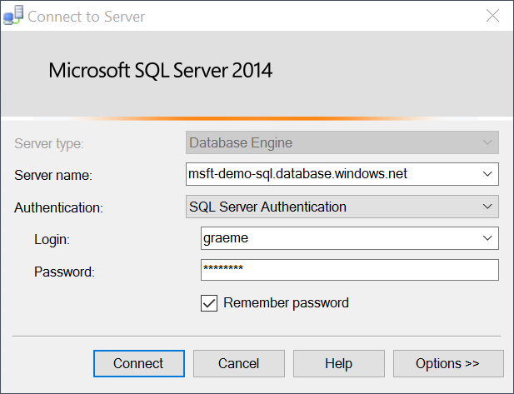

After connecting, you can create a new query and run it by clicking **Execute**, and you can save and open Transact-SQL scripts. Be sure to select the **AdventureWorksLT** database when running your queries as shown here:

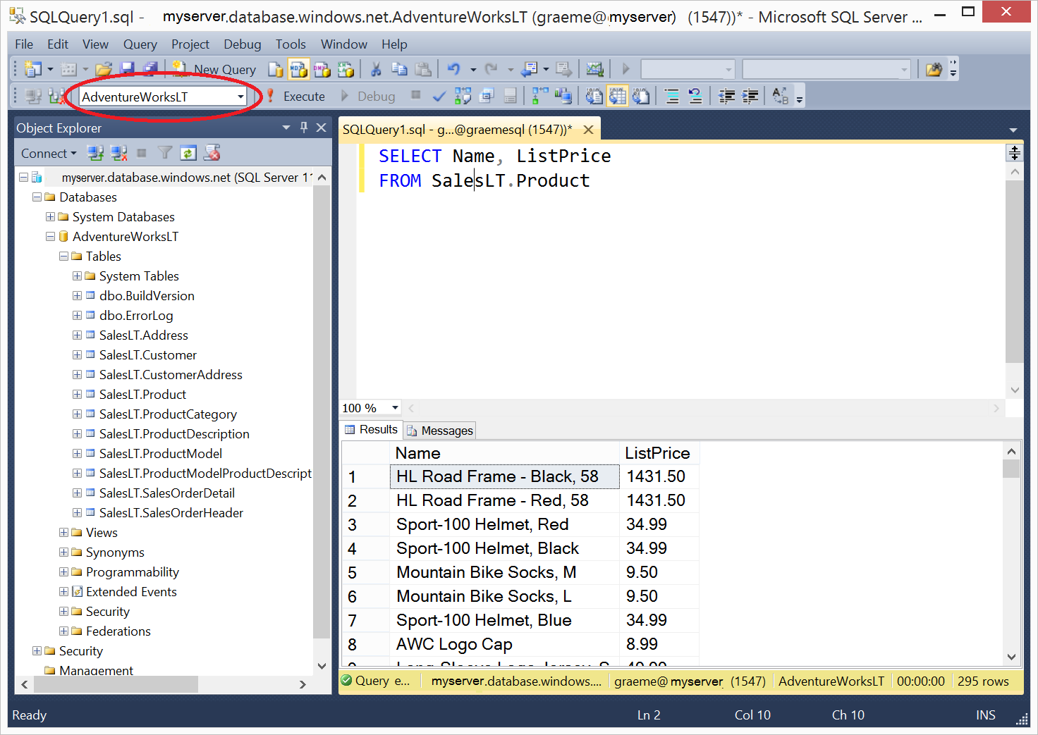

## Microsoft Visual Studio

If you are primarily a developer, you may prefer to use Visual Studio to create your Transact-SQL queries. Visual Studio is a comprehensive software development environment for all kinds of software projects, including database development. You can download the free Community edition of Visual Studio from [www.microsoft.com/vstudio](http://www.microsoft.com/vstudio) and install it on your Windows computer.

When you install Visual Studio, be sure to select the option to include the **SQL Server Data Tools** optional component. Then, in the Server Explorer pane, you can create a data connection to your Azure SQL database server using the **Microsoft SQL Server (SqlClient)** data source as shown here.

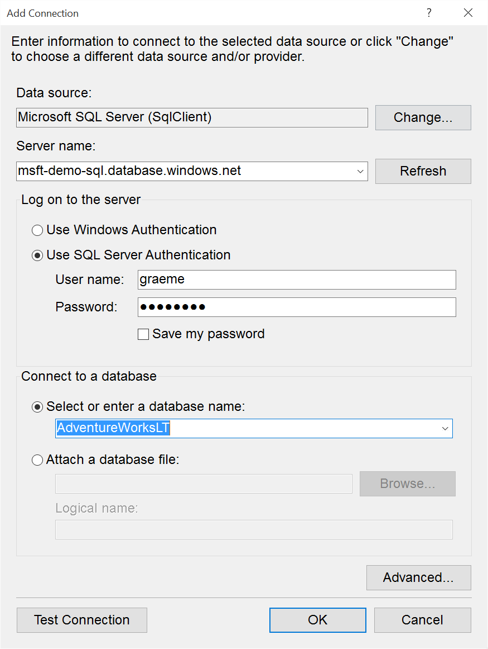

After you have created a data connection, you can view database objects in the Server Explorer window. You can also create and save Transact-SQL scripts and run queries, as shown here.

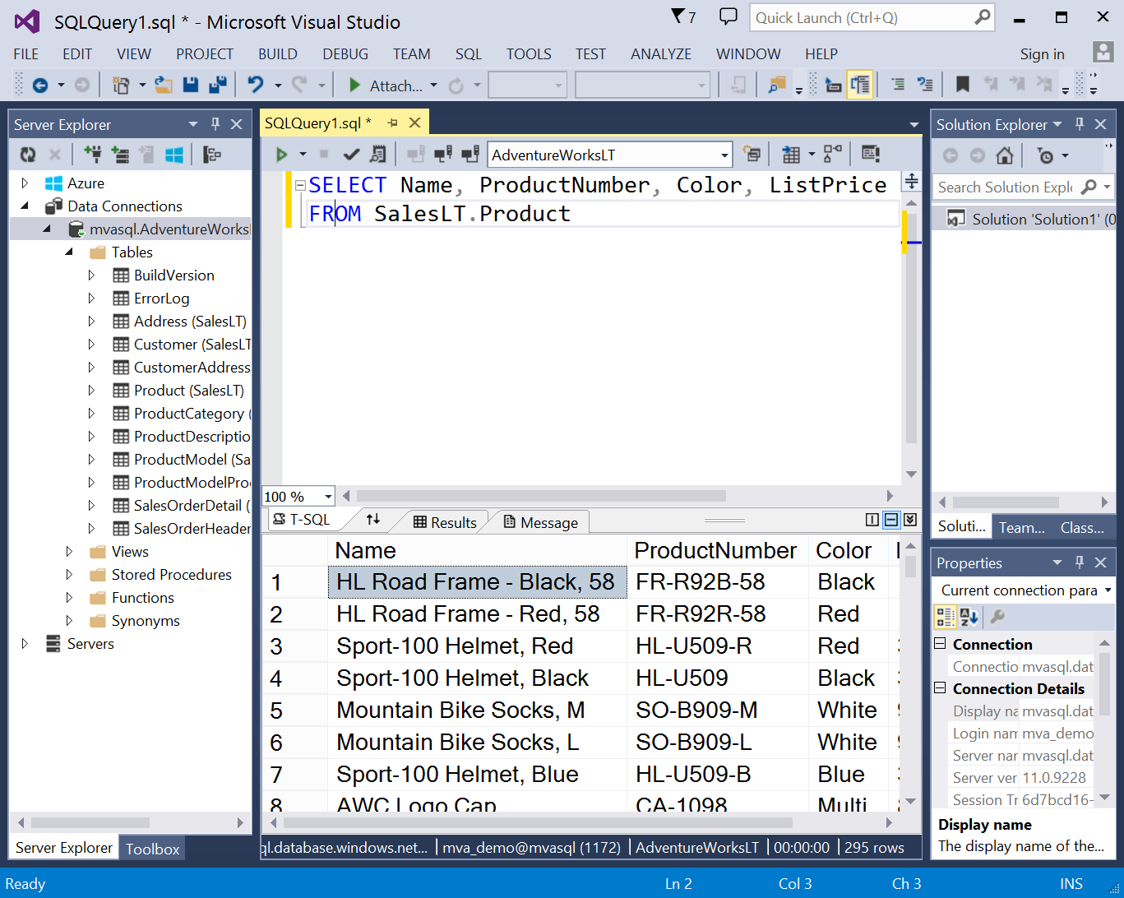

# Alternative Setup using SQL Server Express

The labs in this course are designed to work with Azure SQL Database. For the best experience, sign up for a free Azure trial subscription and follow the instructions provided above. If you are unable to create an Azure subscription, you can use the following instructions to install SQL Server Express on a Windows 7, 8, or 10 computer, and deploy a sample database that is similar to the one used in the labs.

**Note**: These instructions assume you are familiar with Windows and comfortable installing software. The sample database may differ from the Azure SQL Database version, so the solution files provided in the course may not work as expected.

## Install SQL Server 2014 Express

1. Browse to <http://www.microsoft.com/en-us/download/details.aspx?id=42299> and click **Download**. If prompted, sign in with a Microsoft account or create a new one.
2. Select the option for **ExpressAndTools** that is right for your Windows installation (32 Bit or 64 Bit. Then click **Next**.
3. Save **SQLEXPRWT_x*NN*_ENU.exe** (where *NN is 32 or 64*) to a temporary location and then run it after it’s been downloaded.
4. When prompted, choose a folder to which the installation files will be extracted (by default, they are extracted to a folder named **SQLEXPRWT_x*NN*_ENU** on the desktop.
5. If the **SQL Server Installation Center** window does not appear, in the folder where you extracted the files, run **Setup.exe**. Then, in the **SQL Server Installation Center** window, on the **Installation** page, click **New SQL Server stand-alone installation or add features to an existing installation**.
6. In the SQL Server 2014 Setup window; if there are any issues, resolve them by installing any prerequisite software or making any required configuration changes. Then re-run setup.
7. On the **License Terms** page, accept the license terms and click **Next**.
8. On the **Feature Selection** page, select all features and ensure that the installation location has sufficient disk space. Then click **Next**.
9. On the **Instance Configuration** page, select **Default instance** and click **Next** (note, if you wish, you can install a named instance instead of a default instance – if you do this, when you connect to your SQL Server instance you must specify the name **(local)*instance_name***.)
10. On the **Server Configuration** page, do not change the default selections (unless you are comfortable configuring service accounts). Just click **Next**.
11. On the **Database Engine Configuration** page, select **Mixed Mode (SQL Server authentication and Windows authentication)**, enter a suitable password for the system administrator (sa) account (and make a note of it!), and click **Next**.
12. When installation is complete. Click **Close**.
13. Close the SQL Server Installation center window.
14. If you are using Windows 8, on the Start screen, click the down arrow to view all apps, and then right-click **SQL Server 2014 Management Studio** and click **Pin to Taskbar** – this will make it easier to find when you want to use it.

## Install the AdventureWorksLT Sample Database

1. Browse to <http://msftdbprodsamples.codeplex.com/releases/view/55330>, and click the link to download **AdventureWorksLT2012_Data** (be careful to select this download and not one other others). Save the **AdventureWorksLT2012_Data.mdf** file to the **Data** folder for the SQL Server Express instance you installed (by default, this is C:\Program Files\Microsoft SQL Server\MSSQL12.MSSQLSERVER\MSSQL\DATA). Note, you may be prompted to confirm that you want to grant your user account permission to access this location.
2. Start SQL Server Management Studio, and when prompted, enter or select the following options and click **Connect**:
   * **Server type**: Database Engine
   * **Server name**: (local) (or (local)*instance_name* if you installed a named instance)
   * **Authentication**: SQL Server Authentication
   * **Login**: sa
   * **Password**: *The password you specified during installation*
3. If the Object Explorer pane is not visible, on the **View** menu, click **Object Explorer**. Then in Object Explorer, right-click **Databases** and click **Attach**.
4. In the **Attach Databases** dialog box, under the **Databases to attach** list, click **Add**. Then browse to the folder where you downloaded **AdventureWorksLT2012_Data.mdf**, select it, and click **OK**.
5. In the **Attach Databases** dialog box, in the **“AdventureWorksLT2012” database details** area, select **AdventureWorksLT2012_log.ldf** and click **Remove**. Then click **OK**.
6. In Object Explorer, expand the databases folder and verify that the **AdventureWorksLT2012** database is listed.
7. On the toolbar, click **New Query**. Then in the **Available Databases** list, ensure that **AdventureWorksLT2012** is select and type the following query:

SELECT * FROM SalesLT.Product;

1. On the toolbar, click **Execute**, and verify that a table of product data is returned.
2. Close SQL Server Management Studio without saving any files.

# Useful Resources

In addition to the materials provided with this course, you might find the following resources useful as you learn Transact-SQL.

* [**Transact-SQL Reference**](http://msdn.microsoft.com/en-us/library/bb510741.aspx). This online documentation includes a detailed reference to Transact-SQL keywords and syntax.
* [**Microsoft SQL Server 2012 T-SQL Fundamentals**](https://www.microsoftpressstore.com/store/microsoft-sql-server-2012-t-sql-fundamentals-9780735658141)(Microsoft Press, 2012), by Itzik Ben-Gan. This book provides an introduction to Transact-SQL, and complements the content in this course.
* [**Born To Learn**](https://borntolearn.mslearn.net/). Born to Learn is an online community for people learning about Microsoft technologies. By participating in the SQL Server forum at Born To Learn, you can engage with other students all over the world who are studying SQL Server and related technologies.

# Further Learning

Microsoft offers a range of training options on SQL Server and data platform technologies. After you’ve mastered Transact-SQL, you can use the following resources to continue your journey towards becoming a data professional.

* [**Microsoft Virtual Academy**](http://www.microsoftvirtualacademy.com/colleges/MVA-Edx-SQL). Online courses at Microsoft Virtual Academy (MVA) bring you training direct from experts.
* [**Microsoft Official Curriculum**](https://www.microsoft.com/learning). Instructor-led Microsoft Official Curriculum (MOC) courses are delivered in classrooms and online by Microsoft Certified Trainers (MCTs) all over the world.
* [**Microsoft Press**](https://www.microsoftpressstore.com/). Microsoft Press offers multiple series of books for IT professionals and developers. In particular, [**T-SQL Querying**](https://www.microsoftpressstore.com/store/t-sql-querying-9780735685048) (Microsoft Press, 2015), by Itzik Ben-Gan, [Adam Machanic](https://www.microsoftpressstore.com/authors/bio.aspx?a=7f8de15d-9b55-4d2e-9fb9-1f91740c1976), [Dejan Sarka](https://www.microsoftpressstore.com/authors/bio.aspx?a=468621bb-d23d-4ebd-99ec-5547d8a8a716), and [Kevin Farlee](https://www.microsoftpressstore.com/authors/bio.aspx?a=f08bf4b6-9b05-49f8-9c90-f057088544f7) gives database developers and administrators a detailed look at the internal architecture of T-SQL and is the comprehensive programming reference for T-SQL querying.

# Microsoft Certification Exams

The Microsoft Certified Professional program validates skills with Microsoft technologies and awards industry-recognized certifications. This course can help you prepare for exam [70-461: Querying Microsoft SQL Server](https://www.microsoft.com/learning/en-gb/exam-70-461.aspx), which is a required exam for the Microsoft Certified Solutions Associate (MCSA): SQL Server certification.

**Note**: While this course covers many of the core objectives measured by Exam 70-461, the exam may test some additional objectives beyond those covered in this course. Before taking the exam, review the skills measured and ensure that you have supplemented your learning on this course with additional information from [SQL Server Books Online](http://msdn.microsoft.com/en-us/library/ms130214.aspx) or from the sources of further learning listed above.